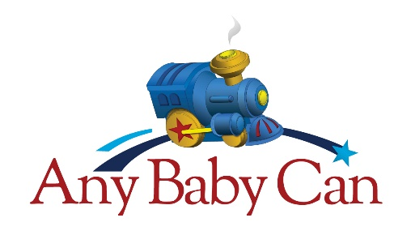

Share the holiday spirit with an Any Baby Can family.

Dear Friend of Any Baby Can,

Any Baby Can of San Antonio is preparing once again to assist families who are caring for children and youth facing serious health or developmental challenges. Each year, many families go without the basic holiday presents or "goodies" that we may take for granted. Many families go without celebrating the holiday season in order to provide essential medications that are not covered by insurance or just basic living expenses such as food and housing. Any Baby Can's Holiday Giving Program offers members of our community a way to get involved and help families raising children with special health care needs.
Because of the generosity of our sponsors, we are celebrating our 37th Anniversary this year and have a goal to support 50 new families.

Here’s how you can help! Please consider sponsoring at least one of our families. Here's what is involved when you or your organization decide to participate:

- You "adopt" a family for the Holidays (you may specify a preference for family size).

- You purchase gifts and holiday meal items for the family (please see attached guidelines).

- You deliver the items on or before December 11, 2020 (exact date & time to be worked out with the family).

To become a part of this rewarding program, please complete the enclosed Sponsor Registration Form and return it via scanned e-mail or fax to Crissy Torres (see contact information below).

If you have any questions, please contact:

Crystal Torres at (210) 547-3004, ctorres@abcsa.org Fax: (210) 227-0812
*Email communication is preferable

When you return your signed agreement to us, we will match you with a family and send you a packet of information about your adopted family.

We thank you for your interest in Any Baby Can and we wish you a wonderful and blessed holiday season!

Deadline for Sponsorship Registration: November 13, 2020

**ONLY monetary or toy donations will be accepted after deadline**

Holiday Giving Program
Sponsor Registration Form

YES! – I/We want share the holiday spirit with an Any Baby Can Family. I/We agree to sponsor:

____# of families with up to ____# of children & up to ____ # of adults in each family

*Please see Sponsor Guidelines (next page) for suggested amounts for each child & adult in the family.

I am not able to sponsor a family, but would love to collect toys for a toy drive or make a monetary
donation to help other families this holiday season.

Name of Sponsoring Individual or Business: ________________________________________________________

Address: __________________________________ City: ________________ State: _________ Zip: ___________

Name of Primary Contact: ______________________________________________________________________

Telephone number: _________________________________________________________________

Email address: _____________________________________________

I can sponsor a family whose primary language is:

English Spanish American Sign Language (ASL) Other___________________

I/We agree to contact the family/families I have requested and will notify them that I/we am/are their assigned sponsor by 11/20/2020. I/We will also make arrangements directly with them for gifts to be delivered prior to Christmas day.
Suggested delivery date: December 11, 2020

If you are unable to reach your family, please contact the Any Baby Can staff member immediately; their information is located on the Family Information Form.

I agree to adhere to the guidelines for sponsorship as outlined in the Sponsor Guidelines.

_______________________________________ ___________________________
Signature of Sponsor Date

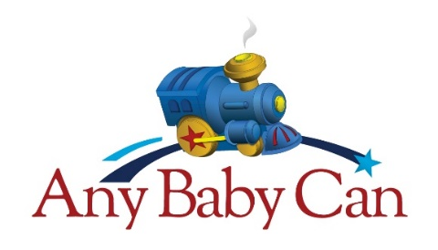

Holiday Giving Program
Sponsor Guidelines

The following are suggested guidelines. They are meant to make the process easier and are simply suggestions. Please feel free to purchase additional items. The Family Information Form, which you will receive once a family has been assigned to you, will provide you with a list of clothing sizes, wish list, food allergies, and other pertinent information that can help you with your purchases.

For Each Child in the home  (suggested gift - $50 per child) | For Each Adult  (one gift per adult) | Food for a Holiday Meal
At least one complete outfit  Three pairs of underwear or packages of diapers  Three pairs of socks  One toy  One book | Gift Cards  Personal hygiene supplies  Blankets  Bedding  Towels | Fresh fruits  Staple foods  Non-Perishables  Holiday treats (cookies, candies, etc.)  Grocery Gift Cards

Please contact your Any Baby Can family once you receive your assignment to schedule a time to meet or ask additional questions you may have before delivery. Please be aware that you may need to call in the evening for those families that are working or out at appointments during the day.

If you encounter difficulty contacting your assigned family, please call the assigned ABC staff member. Their contact information will be listed on your Family Information Form. The ABC staff member can help you reach the family to make delivery arrangements.

Additional Helpful Tips:

- Contact your assigned family to remind them of your scheduled time and date of delivery.
- Ask if the family prefers to have the gift delivery to be made during the day when the children are at school.
- Dress casually when delivering gifts.
- Bring someone with you to share the experience.
- Please be aware that each family's response to holiday gifts is unique; some are very verbal and some are less expressive in their gratitude.
- Please be aware that despite appearances, parents may be struggling with astronomical medical costs for their child's care.

Thank you so much for your participation in Any Baby Can's Holiday Giving Program!
We are excited to work with you to make a difference in our community this holiday season.

Suggested delivery date: December 11, 2020

